Send it
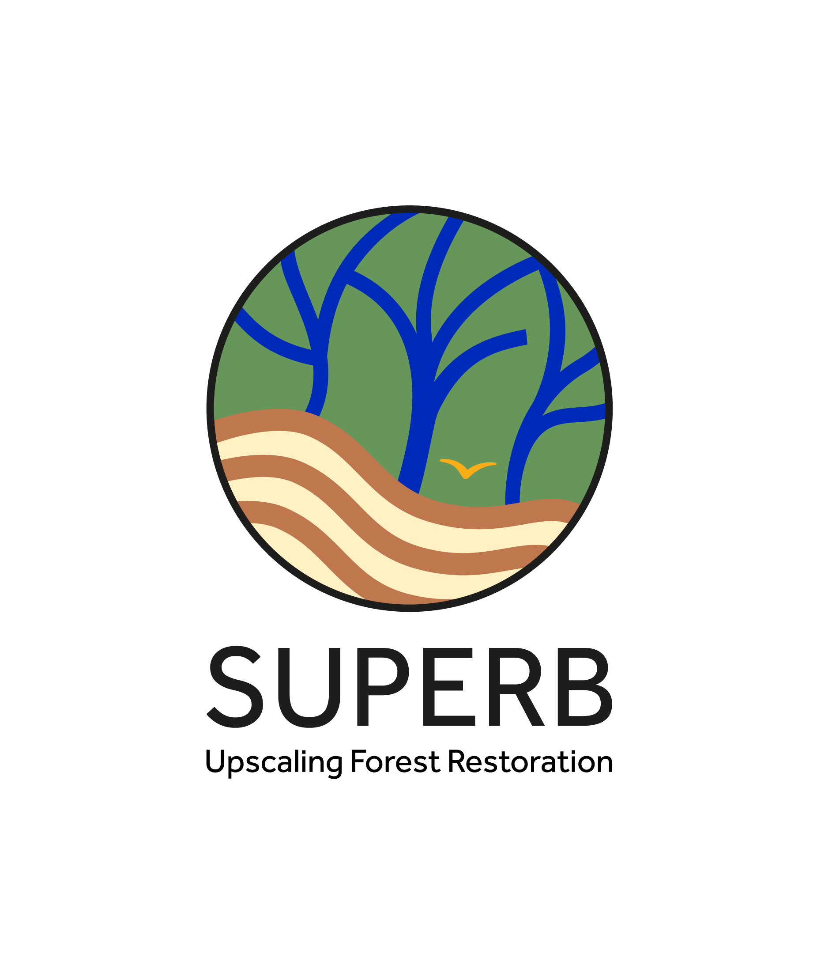
Deliverable D5.3

Public perspectives on forests and forest restoration in Europe
Planned delivery date (as in DoA): M42
Due date of deliverable: 31/05/2025
Workpackage: WP5

Workpackage leader: Marcel Hunziker
Deliverable leader: Marcel Hunziker
Version: 1.0
Dissemination level: CO(nfidential)

Grant Agreement number: 101036849
SUPERB — H2020-LC-GD-2020 / H2020-LC-GD-2020-3
Project Acronym: SUPERB
  - Systemic solutions for upscaling of urgent ecosystem restoration for forest related biodiversity and ecosystem services
  - Duration of the project: December 1st, 2021 - November 30, 2025

VERSION HISTORY
Version | Date | Author /Reviewers | Partner | Description
0.1 | 24.03-2025 | Moses Kazungu and Marcel Hunziker | WSL | Initial draft
0.2 | 28.03.2025 | Simon Fleckenstein and Lyla O`Brien | ALU-FR and EFI | Revision of second draft
0.3 | 12.05.2025 | Reviewer: Jonathan Gray | KCL | Review of draft deliverable 0.1
1.0 | 21.05.2025 | Moses Kazungu and Marcel Hunziker | WSL | Implementation of revision and finalisation of deliverable

CITATION:
Moses Kazungu & Marcel Hunziker (2025). Deliverable 5.3 (D5.3): Public perspectives on forests and forest restoration in Europe. Horizon 2020 Project No. 101036849, European Commission, 16 pp (plus 49 annexes)

DISCLAIMER

The information in this document is provided “as is”, and no guarantee or warranty is given that the information is fit for any particular purpose. The above referenced authors shall have no liability for damages of any kind including without limitation direct, special, indirect, or consequential damages that may result from the use of these materials subject to any liability which is mandatory due to applicable law.
The content of this deliverable does not reflect the official opinion of the European Union. Responsibility for the information and views expressed lies entirely with the author(s).

ACKNOWLEDGEMENT

This project has received funding from the European Union’s Horizon 2020 research and innovation programme under grant agreement no. 101036849.

Table of Contents
Summary 3
Keywords 4
1 Background 5
2 Deliverable outline 5
3 Part A: Report on T5.3 investigations 6
3.1 Aim of task 5.3 6
3.2 Study design and methods 6
3.2.1 Study Design 6
3.2.2 Literature review 7
3.2.3 Study areas 8
3.2.4 Data collection methods 9
3.3 Results overview 11
4 Part B: Toolkit of WP5, including overview of Gateway products as annexes 12
4.1 Directly usable results/data from across Europe 14
4.1.1 Policy analysis 14
4.1.2 Stakeholder perceptions, governance challenges and solutions 14
4.1.3 Societal perceptions and public support for forest restoration 14
4.2 Exemplary results from case studies in WP5 transferable to other areas in Europe 14
4.2.1 Policy analysis 14
4.2.2 Stakeholder engagement and governance 15
4.2.3 Public perceptions 15
4.3 Methods to run own investigations 15
4.3.1 Policy analysis 15
4.3.2 Stakeholder perceptions, governance challenges and solutions 15
4.3.3 Societal perception studies 15
5 References 16

Summary
This deliverable presents the results of Task 5.3 (T5.3) within the Horizon 2020 SUPERB project, focusing on public perceptions of forest benefits, restoration strategies, restoration impacts, willingness to support restoration, and preferred support mechanisms. The objective was to better understand societal demands for forest restoration and provide evidence that can inform the design and implementation of restoration strategies across Europe, ensuring they are socially accepted, policy-relevant, and scalable.
T5.3 was structured into three components: (a) qualitative interviews with experts and key stakeholders in demonstration (demo) regions; (b) a series of regional household surveys exploring public preferences around landscape-level restoration; and (c) an online panel survey conducted across the 12 SUPERB countries, assessing broader attitudes. The combination of these methods provides both contextual and generalisable insights into societal preferences. The research builds on the stakeholder mapping and interviews from Tasks 2.1 and 5.2 and contributes directly to the outputs of WP8 on upscaling.
Across countries and regions, the public strongly values forests for their ecological and social functions. Respondents consistently highlight benefits such as biodiversity conservation, scenic beauty, recreation, and quality of life. In contrast, provisioning benefits—such as berries, mushrooms, timber, and non-edible materials—receive less recognition and show greater variability across countries and regions.
Awareness of forest restoration strategies is generally higher than previously assumed, with respondents—particularly those in regions where restoration is actively implemented—demonstrating greater familiarity. This suggests that the public is relatively well informed about forest restoration efforts in their local environments. Notably, strategies that are more widely recognised tend to be those actively implemented in respondents’ own regions, such as the introduction of fire breaks in Spain and improvements to recreational access in Queen Elizabeth Forest Park (QEFP), Scotland—indicating a coherence between public awareness and on-the-ground restoration practices. While approaches like replanting mixed tree species, improving recreational access, and retaining deadwood are relatively well recognised, many other strategies—including reintroducing native animal species or altering forest management—are less familiar to the public. A high proportion of “don’t know” responses highlights this knowledge gap, particularly among younger and less formally educated groups.
Perceptions of the impacts of forest restoration vary across countries and regions. Restoration is generally viewed as beneficial for aesthetics, recreation, biodiversity, and habitat provision. However, the public is more uncertain about restoration’s effects on provisioning services. Respondents from Eastern European countries report the most positive perceptions of restoration impacts, while regional-level findings indicate stronger support in Scotland, and parts of Central and Southern Europe compared to others.
Willingness to support forest restoration is generally high, with support levels ranging from 52% to 84%across the surveyed countries. Notably, stronger support is observed in several Eastern and Southern European countries, while more neutral responses are common in the Scandinavian region. University-educated individuals and those aged 27–37 show the highest levels of support. Neutral responses are more common among younger and older age groups, while overall opposition remains low across all demographics.
Support preferences reflect a clear public leaning towards institutional mechanisms. The most endorsed actions include using taxpayer funding and advocating for restoration-supportive policies. In contrast, volunteering or donating personal funds receives relatively low support. These patterns are consistent across countries and demographic groups, reinforcing the public’s preference for policy-led, publicly funded approaches to restoration.
Findings from this study point to important implications for forest restoration design and communication. Forest restoration strategies should emphasise visible, socially valued benefits—such as biodiversity, recreation, and aesthetics—over provisioning functions. However, less positively perceived impacts on the latter must be taken seriously and addressed by appropriate communication efforts. Public support is strongest for policy-led and publicly funded initiatives; therefore, less reliance should be placed on personal donations or volunteering. Regional and demographic differences in perception should be considered when designing locally adapted and socially inclusive restoration efforts.
The WP5 toolkit offers practical tools for monitoring, engagement, and informed decision-making to support long-term restoration governance. This outcome is especially relevant for restoration stakeholders including national and regional policymakers, environmental agencies and public authorities, forest managers and landowners, NGOs and community organisations, and researchers and project planners involved in restoration design and evaluation.

Keywords
Forest restoration, societal perceptions, ecosystem services, restoration toolkit, Europe,

Background
The SUPERB (Systemic solutions for upscaling of urgent ecosystem restoration for forest-related biodiversity and ecosystem services) project aims to support large-scale forest restoration across Europe through integrated socio-ecological approaches. As part of this effort, twelve demonstration regions were established in different countries to test and showcase restoration strategies under diverse conditions. Four of them have been selected as upscaling regions—Västerbotten County (Sweden), Queen Elizabeth Forest Park (Scotland), Castilla y León (Spain), and the Serbia-Croatia border region.
Work Package 5 (WP5), and specifically Task 5.3, focused on understanding societal engagement in forest restoration. Within this context, the four upscaling demo regions —plus North Rhine-Westphalia (Germany), representing Central Europe, served as focal areas for intensive data collection through interviews and regional surveys. In addition, national-level surveys were conducted across twelve SUPERB countries: Sweden, Scotland, Denmark, the Netherlands, Germany, France, Italy, Spain, Czech Republic, Croatia, Serbia, and Romania. This dual-scale approach enabled both in-depth regional analysis and broader cross-country comparisons to inform socially supported forest restoration across Europe.

Deliverable outline
This report is structured in two main parts, Part A and Part B.
Part A – Societal Perceptions of forest restoration in Europe (Task 5.3):
This part reports briefly on societal perceptions of forests and forest restoration across twelve European countries as investigated within task T5.3. Drawing on qualitative interviews and on large-scale survey data, it examines how people perceive forest benefits, how they respond to different restoration scenarios, and their willingness to support restoration efforts. This part sets the context for understanding the broader societal demand for restoration.
Part A consists of the following sections:
- Aims of Task 5.3.
- Methods used to explore public perceptions of forests, forest restoration, and associated benefits (methodological details are provided in the annexes of Part B).
- Main findings on societal perceptions of forests and restoration from across the twelve study countries (details again in the annexes of Part B).
Part B – Toolkit Compendium (covering the Gateway products of Tasks 5.1, 5.2, 5.3):
This part brings together outcomes from Tasks 5.1, 5.2, and 5.3 within Work Package 5 (WP5) and presents a practical toolkit, developed to support future monitoring and planning of socially supported forest restoration. The toolkit is designed for immediate application and contributes directly to the outputs of Work Package 8, Task 2 (T8.2). By combining the results of stakeholder interviews, public surveys, and policy analyses, this report equips users with ready-to-use materials for assessing governance and gauging public acceptance of forest restoration across different European contexts
Part B consist of the following sections respectively the corresponding Gateway products (organised as annexes to D5.3 that represent so-called Gateway products which will be included in the final Forest Restoration Gateway of SUPERB):
- Directly usable results from across Europe, including public perception data, policy analyses, and governance assessments.
- Exemplary case study findings from selected regions that are transferable to other European contexts.
- Methods and tools to support independent investigations, including survey instruments, conflict management, guidance on conducting in-depth studies, and policy analysis frameworks.

Part A: Report on T5.3 investigations

Aim of task 5.3
Task aligns with the broader objectives of the SUPERB project by supporting evidence-based decision-making on forest restoration. It aims to deepen understanding of how society at large perceives forest restoration across Europe. Its core objective is to capture public expectations, perceptions of forest benefits and restoration strategies, expected impacts from and levels of support of restoration as well as the socio-demographic and contextual factors that shape these views—filling a critical gap in existing knowledge, which often focuses more on expert or institutional perspectives. The findings are intended to inform the design of restoration strategies that align with societal expectations and are supported across diverse European settings. By doing so, the task directly contributes to one of SUPERB’s specific objectives: to improve societal support for forest restoration and its benefits.
Part A of this deliverable maps demand for ecosystem services and restoration efforts at both local (demo) and European scales. Comparing the views of the general public with those of landowners, managers, and other stakeholders helps reveal areas of alignment and divergence. These insights can inform the development of restoration strategies that are better understood, more widely accepted, and ultimately more sustainable.

Study design and methods

Study Design
The study design of Task 5.3 focused on capturing public perceptions of forest restoration and aimed thereby to identify how different dimensions—such as forest use, perceived benefits, restoration strategies, and socio-demographic factors—influence attitudes toward forest restoration and public support for it.
A conceptual framework was developed to examine these interlinked factors and how they shape people’s views and behaviours regarding restoration (see Figure 1). This framework guided all the empirical investigations and in particular the formulation of survey instruments and the selection of relevant indicators for cross-country comparison.
To investigate the conceptual model (Figure 1) with its components and interactions empirically, we chose a mixed-method approach, including literature review, qualitative interviews and large-scale quantitative surveys:
- To enable operationalisations of the components and interactions of the conceptual model for the later surveys, we conducted a comprehensive literature review, including peer-reviewed and grey literature.
- Qualitative expert interviews with responsible staff of all 12 SUPERB aimed at superficially exploring the public view on forest restoration and to gain information for the sampling of respondents within the next phase of the in-depth key-informant interviews.
- The qualitative in-depth key-informant interviews (Annex SP104) contextualised the literature findings and provided deeper insights into people’s perspectives on forests, forest benefits, and forest restoration. These qualitative insights, combined with the knowledge from published literature, informed the design of survey questionnaires (Annex SP105b).
- The surveys covered the components, including perceptions of behavioural aspects, forest benefits, attitudes towards forest restoration, expected impacts of restoration, and socio-demographic attributes (Figure 1).

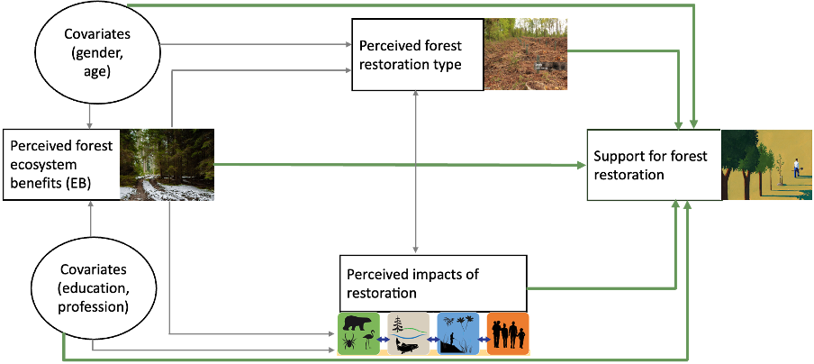
Figure 1: Conceptual model of the relationship between perceived forest ecosystem benefits and support for forest restoration. The bold green lines indicate the key areas of analysis in this report.

Literature review
Forest restoration: A Review of perspectives and practices
A growing body of literature defines forest restoration in diverse ways, underscoring the absence of a universal consensus. This variation largely reflects the differing aims, ecological contexts, and socio-political priorities associated with restoration across regions.
Ecological and functional perspectives
Some scholars define forest restoration primarily from an ecological or functional standpoint. Stanturf et al. (2014) frame forest restoration within four overarching strategies—rehabilitation, reconstruction, reclamation, and replacement—each responding to varying degrees of degradation and ecosystem disruption. Their approach is rooted in restoring ecological processes and enhancing ecosystem sustainability. Similarly, Ciccarese et al. (2012) view forest restoration as a tool to re-establish the presumed structure, productivity, and species diversity of the original forest, while recognising that fully restoring historical conditions may not always be practical. Instead, they advocate for improving ecosystem functions and services under contemporary conditions, particularly to mitigate climate change, protect biodiversity, and support biomass production.
Socio-ecological and policy-oriented perspectives
In contrast, other authors highlight the need to integrate both human and ecological dimensions. Mansourian et al. (2017), writing from the standpoint of Forest Landscape Restoration (FLR), stress that restoration must be intentional, multifunctional, and inclusive. FLR, therefore, promotes restoration that enhances both ecological integrity and human well-being. Halme et al. (2013) further argue that restoration should be rooted in a solid ecological understanding of the target ecosystem.
Reconciling the different perspectives
Taken together, these views demonstrate that forest restoration is not a single, fixed process. It can range from restoring natural fire regimes and planting native species to managing multifunctional landscapes through agroforestry or community-based initiatives. While ecological goals such as enhancing biodiversity and ecosystem function remain central, restoration increasingly involves social engagement, governance reform, and livelihood integration.
In this report, we define forest restoration as referring to actions to renew and improve damaged forests’ health, structure, and functioning. It involves various activities such as planting trees, managing vegetation, controlling invasive species, or restoring natural processes to conserve and strengthen forest ecosystems. As such, people can participate in forest restoration in multiple ways—either by supporting relevant policies or by engaging directly in restoration activities.

Study areas
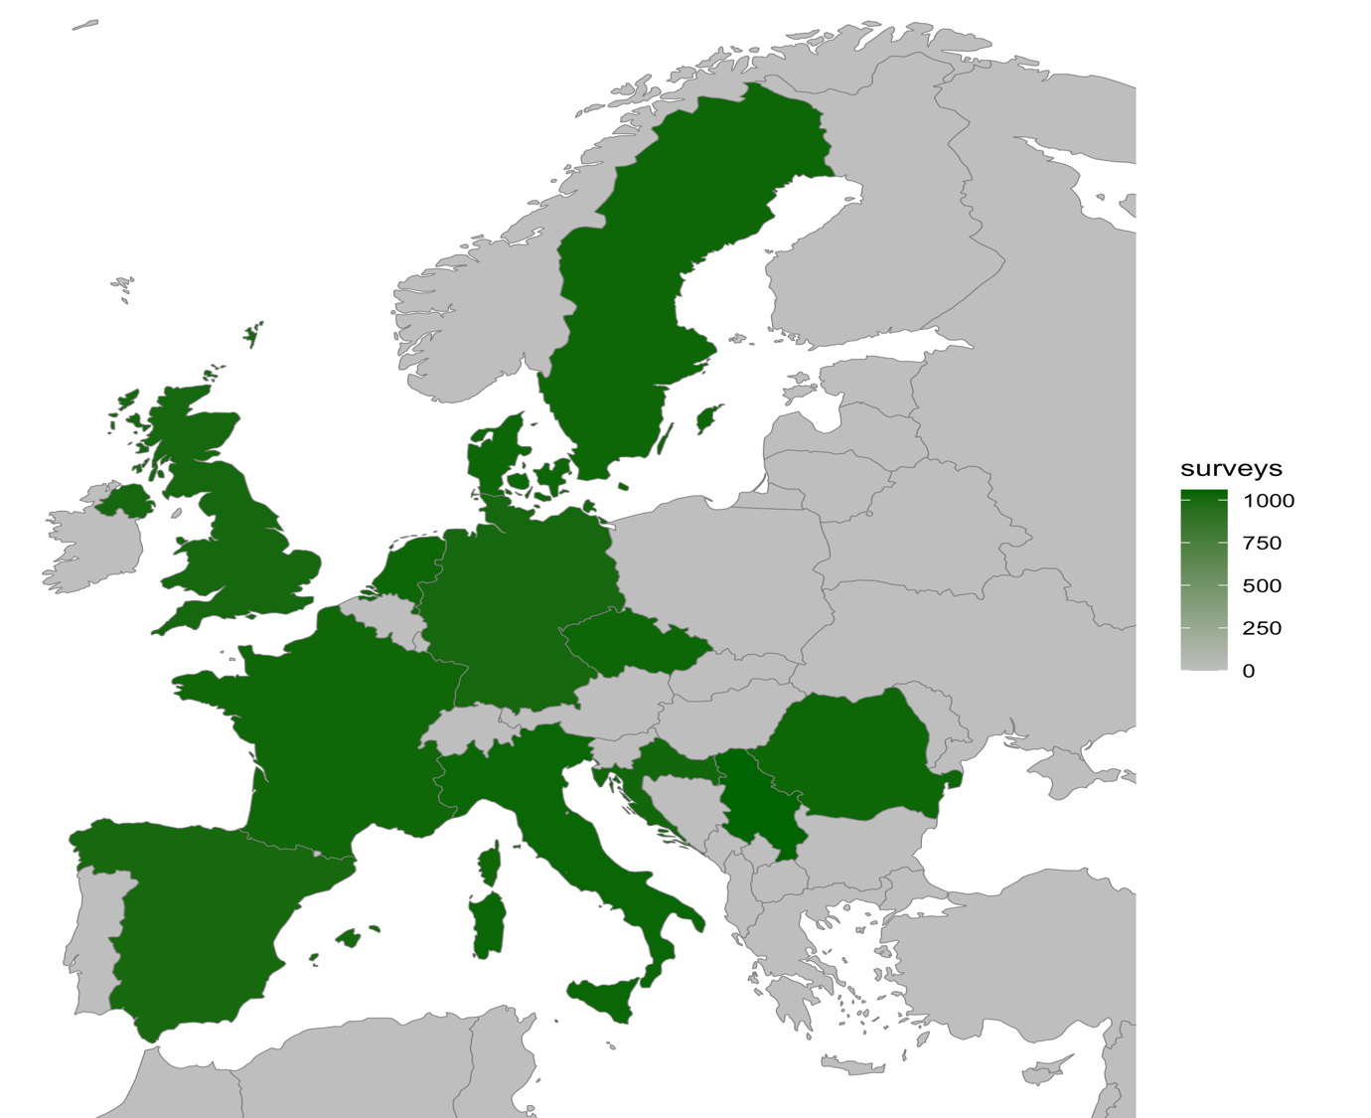
SUPERB Task 5.3 conducted studies in four upscaling regions: Västerbotten County (Sweden), Queen Elizabeth Forest Park (Scotland), Castilla y León (Spain), and the border region between Serbia and Croatia. In addition, North Rhine-Westphalia (NRW) in Germany was included to incorporate perspectives from Central Europe.
Figure 2 shows a map of Europe highlighting the SUPERB countries
Large-scale national studies were also undertaken in twelve SUPERB study countries: Sweden, Scotland, Denmark, the Netherlands, Germany, France, Italy, Spain, Czech Republic, Croatia, Serbia, and Romania (see Figure 2). These countries were selected to represent the geographical diversity of Europe.
Studies in the upscaling regions focused on municipalities where SUPERB forest restoration sites are located, as well as surrounding areas. The national-level studies were designed to be representative, providing insights into public perceptions of forest restoration across the continent.

Data collection methods
This section briefly outlines the data collection methods applied. Further methodological details are available in the Gateway products (Annexes SP104–105) in Part B of this report.

Qualitative approaches: Interviews
Expert interviews
Expert interviews were conducted across all 12 study countries to establish a foundational understanding of national forest contexts, including restoration policies, regulatory frameworks, governance systems, and pressing environmental or socio-political challenges (O’Brien et al., 2025).
Initial discussions were held with regional leads or staff associated with the 12 demonstration areas. These experts were actively involved in forest restoration initiatives or worked within related institutions. The interviews, conducted in collaboration with Task 5.2, were exploratory and semi-structured, allowing for the emergence of region-specific themes while maintaining a degree of consistency across contexts (Kazungu & Hunziker, 2025; O'BRIEN et al., 2025). This flexible approach enabled researchers to accommodate diverse institutional settings and governance arrangements while fostering a richer understanding of stakeholder dynamics and restoration priorities.
Crucially, the insights derived from these expert interviews were used to shape the thematic structure and content of the subsequent key informant interviews conducted in selected regions. They also informed the sampling strategy for identifying knowledgeable and contextually relevant informants who could provide deeper insights into public perceptions and forest use.

In-depth key informant interviews
Twenty in-depth interviews were conducted with selected stakeholders across five demonstration regions to better understand local expectations and acceptance of forest restoration (Kazungu & Hunziker, 2025). The selected regions—Sweden, Scotland, Spain, Serbia/Croatia, and Germany—were part of the SUPERB project's upscaling phase, with Germany included to capture perspectives from Central Europe.
Key informants were identified through a purposive and iterative sampling approach developed in collaboration with demonstration leads. Between three and five individuals were selected per region, prioritising those with substantial knowledge of forest use, restoration efforts, and local environmental governance. The informants included representatives from local authorities, forestry departments, NGOs, and community-based initiatives involved in forest-related decision-making.
The interviews followed a semi-structured format, allowing for flexibility while focusing on key themes identified in earlier expert interviews. This approach facilitated a deeper exploration of public attitudes, socio-cultural values, and perceived barriers or enablers to forest restoration at the regional level. Insights from these interviews directly informed the design and contextualisation of the subsequent public survey questionnaires and contributed to a more nuanced understanding of region-specific dynamics influencing restoration efforts.

Quantitative approaches: Surveys
Regional household surveys
Following the key informant interviews, survey questionnaires were developed based on qualitative findings, consultations with demo leads, and contributions from Task 5.2. Particular attention was paid to aligning the survey with local contexts while drawing from international literature on public attitudes and preference formation. A combination of peer-reviewed and grey literature was used to ensure a comprehensive and context-sensitive instrument.
Household surveys were administered between March and May 2024 in the following regions:
- Västerbotten County, Sweden
- Queen Elizabeth Forest Park, Scotland
- Castilla y León Region, Spain
- Serbia/Croatia border area
- North Rhine-Westphalia (NRW), Germany
A total of 422 responses were collected (n = 422) (see SP105a for methods).

European online panel surveys
To achieve broader coverage, online panel surveys were implemented across all twelve SUPERB countries, as well as in selected subnational regions such as Milan, NRW, and eastern Netherlands, between September and October 2024. These surveys targeted nationally representative quota samples of the general public, ensuring cross-country comparability. In each country, over 1,000 respondents participated, resulting in a total of 12,343 completed surveys (n = 12,343). Additional panel surveys were conducted in: Milan, Italy (n = 167), NRW, Germany (n = 415) and Eastern Netherlands (n = 112). Findings were analysed at both national and regional levels and compared with results from the regional household and forest-professionals surveys to provide a comprehensive understanding of public and expert perspectives on forest restoration. The data support cross-country comparisons within the SUPERB project and contribute to advancing methods for monitoring the social, ecological, and economic dimensions of restoration across diverse European contexts.

Survey of forest professionals
Between December 2024 and March 2025, a targeted survey was conducted among individuals working in or closely affiliated with forest-related sectors. Respondents included professionals from forestry agencies, environmental and nature conservation organisations, and researchers from academic and research institutions. A total of 86 responses were collected (n = 86). This survey aimed to capture expert views on forest restoration, including perceived benefits, restoration priorities, and preferred approaches to public engagement. These insights complement those from the public surveys, offering a sector-specific perspective informed by professional experience and policy involvement.

Data processing
Data processing was carried out using multiple software tools, primarily R and SPSS, which were essential for data cleaning, validation, and analysis.
The first step in the processing workflow involved screening for implausible or invalid responses. These typically included surveys that were only partially completed or left entirely blank. Such incomplete responses usually arise due to non-response or when a participant chooses to opt out of the survey part-way through. These invalid entries were excluded from the dataset prior to any analysis, as this step is critical to ensure data quality and integrity.
Following this, the dataset was analysed using both descriptive and quantitative approaches. Descriptive analysis was used to explore general patterns and trends, helping to build a foundational understanding of public perspectives on forests and restoration. This approach provides rich insights into attitudes and values, supporting a nuanced interpretation of the survey data.
Quantitative analysis, including regression and multivariate techniques, was used to examine the factors influencing public support for forest restoration. While this report focuses primarily on descriptive results—presented in detail in the annexes—the results from the multivariate models will be published separately in peer-reviewed journals. These modelling results will complement the descriptive findings and contribute to a deeper understanding of what shapes restoration support across different contexts.

Results overview
(Details are provided in the WP5 Toolkit, respectively the Gateway products, organised as annexes of D5.3 – see Part B)
The results for Task 5.3 are presented in the form of annexes, which form part of the WP5 Toolkit and Gateway outputs. Country-specific findings are available for each of the twelve study countries: Sweden, Scotland, Denmark, the Netherlands, Germany, France, Italy, Spain, Czech Republic, Croatia, Serbia, and Romania. Each annex includes results on public perceptions, key insights, and policy recommendations tailored to the respective national context.
In addition to these national-level analyses, a comparative assessment across all twelve countries, regional samples, and professional respondents has been conducted. This provides a broader understanding of shared patterns, notable differences, and emerging trends in public support for forest restoration across Europe (see SP101m).
This subsection briefly reports the general outcomes from the national, regional, and forest-professionals surveys on perceptions of forest benefits, familiarity with restoration strategies, perceived impacts of restoration, willingness to support restoration, and preferred modes of engagement across Europe. While detailed results are provided in the annexes, this summary highlights shared patterns and notable contrasts across countries—particularly for readers with an interest in European forest policy and practice.

Common perceptions across Europe:
Forests are broadly valued for their emotional, aesthetic, and ecological benefits, with particular emphasis placed on their role in providing habitats and protecting against natural hazards. These values are consistently recognised across national, regional, and professional respondents. In contrast, provisioning benefits—such as medicinal herbs, berries, and non-edible materials—tend to receive lower levels of recognition, particularly in Western and Northern Europe.

Familiarity with restoration strategies:
Public awareness of forest restoration strategies is higher than previously assumed. Commonly recognised measures include the retention of deadwood, replanting of mixed tree species, reforesting fallow areas, and improving recreational access. Responses at the regional level are more differentiated, with some participants identifying gaps in local implementation—suggesting a more nuanced awareness shaped by proximity to, and experience of, restoration activities.

Perceived impacts of restoration:
Perceptions of the impacts of forest restoration on forest benefits vary across countries, with both positive and cautious views reported. The most favourable perceptions are found in Eastern Europe—particularly in Romania, Serbia, and Croatia—where respondents report strong improvements in aesthetics, habitat quality, and recreational value. Regionally, Scottish and Spanish respondents show greater confidence in restoration outcomes, while participants from Sweden and Serbia/Croatia are more cautious, particularly concerning cultural and social benefits.

Willingness to support restoration:
There is broad public willingness to support forest restoration across Europe, with particularly strong support in Southern and Eastern countries such as Serbia, Romania, and Spain. Neutral attitudes are more common in Northern and Central countries, including the Netherlands, Denmark, and Sweden, although outright opposition remains low. National-level respondents report the strongest willingness to support, followed by professionals. Regional respondents express more cautious support—potentially reflecting more direct experience with local implementation and outcomes.

Preferred support mechanisms:

Across countries, respondents tend to favour institutional and collective support mechanisms—such as supporting policy advocacy and endorsing the use of taxpayers’ money—over more direct, individual contributions. Engagement through volunteering, donations, or awareness campaigns varies more between countries, indicating that while there is strong underlying public commitment, support is often strongest when framed as a shared societal responsibility.

Part B: Toolkit of WP5, including overview of Gateway products as annexes
The toolkit presents the Gateway products developed under Work Package 5. These include directly usable outputs from all twelve study countries across Europe—covering databases, policy coherence analyses, stakeholder perception and conflict management tools, as well as findings on public perceptions. In addition, it features exemplary, transferable case study results from selected regions, highlighting context-specific insights into forest governance and restoration challenges. The toolkit also includes methodological guidance for conducting similar studies, covering both qualitative and quantitative approaches.
An overview of these components is provided in Table 1, while the general content of the nine cells of the table is described in Chapters 5.1–5.3. The Gateway product SP1 serves as a guide to help users identify which of the nine cells and associated products best suit their needs. All Gateway products are organised as annexes to Deliverable D5.3 and are intended to serve as standalone resources within the Forest Restoration Gateway.
The decision support tool SP1, included as the main annex, enables users to navigate the most relevant findings and methods according to their specific needs. It functions as a comprehensive resource for decision-makers and restoration practitioners—offering orientation on whether to consult key results, explore examples, or apply particular methodological approaches. Complementary annexes provide country-level insights, exemplary findings, and methodological details, all of which are cross-referenced within the tool for ease of use.

Table 1. Toolkit outline for monitoring social, governance, and policy aspects of forest restoration
(the SP-numbers refer to the numbers of the annexes of the deliverable D5.3 that represent respective Gateway-products)
Chapters | Policy analysis | Stakeholder perceptions, governance challenges and solutions | Societal perceptions and preferences
SP1: Overview enabling the user to select the adequate products from those within the nine cells of this table.
5.1 Directly usable Results | SP98: Forest restoration policy and legal database.  SP99 a–l: Country reports on policy coherence (link to restoration narratives WP3).  SP97: EU forest restoration policy coherence (including expert matrix)  SP100 a–e: Policy maps (geographical); 5 indicators. | SP86&87: Paradigms in stakeholder understandings of forest restoration.  SP85&87: Forest restoration conflict types (value and interest-based) and potential solutions. | SP101a–l: Public perception towards forests, forest restoration and support for forest restoration across in 12 study countries.  SP101m: Comparison of outcome across all study countries and upscaling regions.
5.2 Exemplary, transferable results (Case studies) | SP99 a–l: Country reports on policy coherence.  SP100: Policy maps (geographical); 5 indicators.  (Possibly also SP98 if policy database will be included as standalone GW product) | SP 106, 107&108: Case study-based forest restoration governance challenges and conflicts and potential solutions. | SP102 a–c: Public perception towards forests, forest restoration and support for forest restoration across in region in Italy (Milan), Germany (NRW), and the Netherlands (East).  SP109: Exploratory results from Upscaling regions plus Germany (Publication).  SP110: Model results for factors affecting restoration (Planned publication).
5.3 Methods to run own surveys | SP97: Framework for cross-sectoral and multi-level policy coherence analysis.  SP98: Policy identification and restoration policy database  SP100 a-e: Policy maps (geographical); 5 indicators | SP104: Guidelines on conducting in-depth studies (joint product with 5.2 & 5.3) (in prep)  SP84: Guidance on conducting a conflict management workshop. | SP104: Guidelines on conducting in-depth studies (joint product with 5.2 & 5.3) (forthcoming)  SP105 a&b: Quantitative household surveys. Description of methods for investigating public opinions and perceptions; stated and intended behaviour). Survey instruments for 12 countries

Directly usable results/data from across Europe
This subsection presents key findings from the twelve SUPERB partner countries across Europe, focusing on societal perceptions of forest restoration, its perceived benefits, relevant policy frameworks, and stakeholder perspectives. These results are essential for policymakers, practitioners, and stakeholders when designing and implementing forest restoration initiatives.
The outputs are categorised into three thematic areas:

Policy analysis
This includes an assessment of forest restoration policies, legal frameworks, and actor networks across Europe. Findings are presented in the form of a restoration policy and legal database (SP98), country-specific policy coherence reports (SP99a–l), EU forest restoration policy coherence (including expert matrix) (SP97), and geographical policy maps covering regulatory provisions included in the national Forest Acts of all EU-MS 27 on five key forest restoration indicators and practices (SP100 a–e).

Stakeholder perceptions, governance challenges and solutions
This explores stakeholder perceptions of forest restoration, forest restoration conflict types, and potential solutions and management strategies for conflicts and other governance challenges. Findings are presented in the form of an overview of stakeholder perceptions of forest restoration (SP84, 87), typical forest restoration conflicts and potential solutions (SP85, 87), case study examples of forest restoration governance challenges and conflicts (SP106, 107, 108), and guidance on conflict management (SP84).

Societal perceptions and public support for forest restoration
This result offers insights into public perspectives on forests and restoration across the twelve SUPERB partner countries in Europe. It includes a decision-support tool (SP1), public perception reports for each country (SP101a–l), and comparative analyses across countries, as well as among national, regional, and professional respondents (SP101m).
Together, these directly usable outputs offer comprehensive coverage of public and professional perspectives, governance challenges and solutions, and policy coherence, forming a robust foundation for restoration planning, monitoring, and stakeholder engagement across Europe. They are provided as annexes in the SUPERB toolkit for use in the Gateway.

Exemplary results from case studies in WP5 transferable to other areas in Europe
This subsection presents illustrative case study results that showcase how WP5 tools and findings can be applied in different contexts. Unlike the broader outputs in Section 3.1, these case-specific insights highlight the toolkit’s adaptability at regional and national scales.

Policy analysis
Case study examples of policy coherence and governance challenges are presented in SP99a–l and in SP100: Policy maps (geographical); 5 indicators.

Stakeholder engagement and governance
Case-specific insights into forest restoration conflicts, governance challenges in Sweden, the Netherlands, and Germany are included as SP106, SP107, and SP108.

Public perceptions
Case-specific studies on public attitude on forests, and support for forest restoration for Netherlands (East), Germany (NRW), and Italy (Milan) are included as SP102 a–c: In addition, exploratory results from Upscaling regions plus Germany and model results (published/under review) are presented as summaries of the publication as SP109 and SP110.

Methods to run own investigations
This subsection provides practical guidance for stakeholders, researchers, and policymakers wishing to replicate or adapt the methods used in WP5. It outlines the tools and procedures for collecting and analysing data on forest restoration from social, policy, and governance perspectives.
The methods are organised into the following categories:

Policy analysis
Guidance on assessing cross-sectoral and multi-level policy coherence, including use of SP97 and SP98 for policy mapping and actor analysis.

Stakeholder perceptions, governance challenges and solutions
Includes SP84 and SP104, which offer conflict management workshop guidelines, and guidance and conducting in-depth studies protocols.

Societal perception studies
Describes instruments used for in-depth interviews (SP104) and household surveys (SP105a–b), including sampling strategies, questionnaire design, and behavioural assessment techniques.
Lastly, the annexes also include a methods decision-support tool (SP1) to help users select appropriate techniques based on their research needs. These methodological resources provide a foundation for future investigations, supporting public engagement, governance analysis, and the integration of social dimensions into restoration planning.

References

Ciccarese, L., Mattsson, A., & Pettenella, D. (2012). Ecosystem services from forest restoration: thinking ahead. New Forests, 43(5), 543-560.

Fleckenstein, S. (2024). From sectoral policy change to cross-sectoral (dis) integration? A longitudinal analysis of the EU's forest and rural development policy. Forest Policy and Economics, 169, 103319.

Halme, P., Allen, K. A., Auniņš, A., Bradshaw, R. H. W., Brumelis, G., Čada, V., Clear, J. L., Eriksson, A. M., Hannon, G., Hyvärinen, E., Ikauniece, S., Iršenaite, R., Jonsson, B. G., Junninen, K., Kareksela, S., Komonen, A., Kotiaho, J. S., Kouki, J., Kuuluvainen, T., . . . Zin, E. (2013). Challenges of ecological restoration: Lessons from forests in northern Europe. In Biological Conservation (Vol. 167, pp. 248-256).

Kazungu, M., & Hunziker, M. (2025). Exploring societal perceptions of forests, ecosystem benefits, and restoration. A case study in Sweden, Scotland, Germany, Serbia, Croatia, and Spain. JOURNAL OF ENVIRONMENTAL PLANNING AND MANAGEMENT, 1-23.

Mansourian, S., Stanturf, J. A., Derkyi, M. A. A., & Engel, V. L. (2017). Forest landscape restoration: increasing the positive impacts of forest restoration or simply the area under tree cover? Restoration Ecology, 25(2), 178-183.

O'BRIEN, L., KONCZAL, A., BEGEMANN, A., LOVRIC, M., LOVRIC, N., FLECKENSTEIN, S., & WINKEL, G. (2025). Forest restoration paradigms and conflicts in Europe. International Forestry Review.

Stanturf, J. A., Palik, B. J., & Dumroese, R. K. (2014). Contemporary forest restoration: A review emphasizing function. Forest Ecology and Management, 331, 292-323. https://doi.org/https://doi.org/10.1016/j.foreco.2014.07.029

